Phase 1
Goal: building a clean and testable scheduler core.
Phase 1 should mean:
“I can create processes, put them into priority queues, and correctly choose which process should run next using priority-based round robin.”
To satisfy Phase 1 properly we need:
- Process representation
- Process states
- Ready queues
- Queue operations
- Scheduler selection logic
- A simple test in main()
- Compilation and successful run in Linux terminal

By the end of Phase 1, the program should be able to do the following:
- define a few processes
- assign them priorities
- place them in ready queues
- select the next process correctly:
  - highest priority first
  - FIFO within same priority

Steps:
- process.h
- queue.h
- queue.c
- scheduler.h
- scheduler.c
- main.c
- Makefile

Phase 2
Goal: Making the scheduler actually run over time
By the end of Phase 2, the program should be able to:
- simulate time using ticks
- admit processes when their arrival time comes
- run one process at a time
- decrease burst time each tick
- decrease time slice each tick
- preempt a process when its quantum expires
- terminate a process when its burst finishes
- print what happens tick by tick

We do all that by making changes to our main.c from a one-time test program into a time-based simulation program.
Right now, our code from Phase 1 does this:
- puts processes into queues
- calls getNextProcess()
- prints the selected order and stops

For Phase 2, we need to make main.c behave like a CPU over time
So instead of asking “who runs next?” only 3 times, it now asks the same question at every clock tick

Features of phase 2:
- Arrival Time Handling
A process should not be ready from the beginning unless its arrival time is 0

So for example if
- P0 arrives at tick 0
- P1 arrives at tick 2
- P2 arrives at tick 4
at tick 0, only P0 can enter the ready queue.

- Current Running Process
At any moment, only one process should be on the CPU

This is tracked by using a variable int currentPid = -1;
-1 means CPU is idle
Otherwise, it will store the PID of the running process

- Tick Loop
Basically, the fake clock of our scheduler

int tick = 0;
while (completed < PROCESS_COUNT) {
...
tick++;
}

Each time the loop repeats, one time loop passes.

- Quantum Countdown
Key idea: If time slice is 2, then a running process can only run for 2 ticks before preemption

To take care of that, at every tick, this happens:
processes[currentPid].timeSliceRemaining--;

- Burst Countdown
Key idea: how much CPU work the process still needs

Handled by this:
processes[currentPid].timeSliceRemaining--;
at every tick.
- Preemption
If a process uses up its time slice but still has work left, it should be removed from CPU and placed back into the ready queue.

- Termination
If a process finishes all its CPU work (i.e. remainingTime == 0) it should be marked terminated and never scheduled again.

- Console Logging
At each tick, print what has happened. That way we can monitor if our logic is working
P1 arrived P0 scheduled P0 running P0 preempted P2 terminated

Most of the Phase 2 work happens in main.c.
main.c code is updated/replaced by its phase 2 version which has a tick-based structure.
Area | Phase 1 main.c | Phase 2 main.c
Purpose | Tests if priority queues work | Simulates actual CPU scheduling over time
Process Count | 3 hardcoded processes | 4 hardcoded processes
Arrival times | Not really used | Actively used
Scheduling | Calls getNextProcess() manually 3 times | Automatically schedules when CPU is free
Time simulation | No concept of time | Uses tick to simulate clock time
CPU tracking | No running process variable | Uses currentPid to track the running process
Process execution | Processes do not actually “run” | Processes run one tick at a time
Burst time | Stored but not reduced | remainingTime decreases every tick
Time slice | Stored but not used | timeSliceRemaining decreases every tick
Preemption | Not present | Process is preempted when quantum expires
Requeuing | Only initial enqueueing | Processes are requeued after quantum expiry
Termination | Not present | Process terminates when remaining time reaches 0
Loop | No main simulation loop | Uses while (completed < PROCESS_COUNT)
Completion tracking | Not present | Uses completed count
Output | Only prints scheduled order | Prints tick-by-tick events
CPU idle handling | Not present | Prints CPU is idle when no process is ready

Phase 1 answered the question “If I have ready processes in queues, can I pick the right one?”
It proved:
- higher priority is selected first
- FIFO works inside the same priority queue
But it did not simulate actual execution.

Phase 2 answers a much more important question:
“Can my scheduler manage processes over time like a real CPU scheduler?”
Inside the loop, it does real scheduler-like actions like decreasing a process’ remaining time and remaining time slice. Process’ in phase 2 aren’t just selected but they also consume simulated CPU time.

In phase 2:
- processes arrive at different times
- the CPU may be idle
- one process runs
- another may arrive later
- a process may be preempted
- a process may finish
- the scheduler must keep making decisions again and again
That is much closer to real operating system scheduling.
Our project is supposed to demonstrate a priority based preemptive scheduler with round robin behavior and phase 2 shows:
priority-based selection + actual execution + time slicing + preemption
To summarize, phase 2 simulates the life cycle of processes by incorporating state transitions like
- NEW READY
- READY RUNNING
- RUNNING READY
- RUNNING TERMINATED

Phase 3
Goal: Adding measurable proof that our scheduler works: per-process statistics and context-switch counting.
Phase 3 should calculate and display:
- completion time
- turnaround time
- waiting time
- response time
- context switches
- average waiting time
- average turnaround time
- average response time

Once again, only main.c needs to be modified

Adding a context switch counter
Replacing this: int completed = 0;
int tick = 0;
int currentPid = -1;

With this: int completed = 0;
int tick = 0;
int currentPid = -1;
int contextSwitches = 0;

Every time the scheduler selects a new process to run, that counts as a context switch in our simulation.

Counting context switches when a process is scheduled
This:
if (currentPid == -1) {
currentPid = getNextProcess(readyQueues);
if (currentPid != -1) {
processes[currentPid].state = RUNNING;
if (processes[currentPid].responseTime == -1) {
processes[currentPid].responseTime = tick - processes[currentPid].arrivalTime;
}
printf("P%d scheduled\n", currentPid);
}
}

Is replaced with:
if (currentPid == -1) {
currentPid = getNextProcess(readyQueues);
if (currentPid != -1) {
processes[currentPid].state = RUNNING;
contextSwitches++;
if (processes[currentPid].responseTime == -1) {
processes[currentPid].responseTime = tick - processes[currentPid].arrivalTime;
}
printf("P%d scheduled\n", currentPid);
}
}

This records how many times the CPU switched to a process

Adding the final statistics table
This is added:
float totalWaitingTime = 0;
float totalTurnaroundTime = 0;
float totalResponseTime = 0;

printf("\nFinal Process Statistics:\n");
printf("PID\tPriority\tArrival\tBurst\tCompletion\tTurnaround\tWaiting\tResponse\n");

for (int i = 0; i < PROCESS_COUNT; i++) {
processes[i].turnaroundTime = processes[i].completionTime - processes[i].arrivalTime;
processes[i].waitingTime = processes[i].turnaroundTime - processes[i].burstTime;

totalWaitingTime += processes[i].waitingTime;
totalTurnaroundTime += processes[i].turnaroundTime;
totalResponseTime += processes[i].responseTime;

printf("P%d\t%d\t\t%d\t%d\t%d\t\t%d\t\t%d\t%d\n",
processes[i].pid,
processes[i].priority,
processes[i].arrivalTime,
processes[i].burstTime,
processes[i].completionTime,
processes[i].turnaroundTime,
processes[i].waitingTime,
processes[i].responseTime);
}

printf("\nAverage Waiting Time: %.2f\n", totalWaitingTime / PROCESS_COUNT);
printf("Average Turnaround Time: %.2f\n", totalTurnaroundTime / PROCESS_COUNT);
printf("Average Response Time: %.2f\n", totalResponseTime / PROCESS_COUNT);
printf("Total Context Switches: %d\n", contextSwitches);

return 0;
}
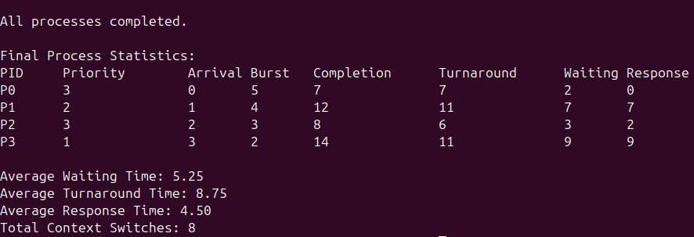

Phase 4
Goal: Making the scheduler usable beyond hardcoded testing (one path for automatic demo scenarios and one path for user-entered manual workloads)
The biggest downside so far in all the progress we’ve made has been the hardcoded data.
Every run uses the same fixed process list.
Our project is supposed to support both manual workload mode and automatic workload replay mode for testing and demonstration. So, in phase 4 the program will now be asking the user:
    - Manual mode
    - Automatic mode
Enter your choice:

By the end of Phase 4, our program will be able to support:
Manual Mode where the user enters:
- number of processes
- arrival time
- burst time
- priority
- time slice
Automatic Mode where the program uses predefined test data like before, but this mostly just for quick demonstration to show the scheduler’s functionality without typing everything.
These 4 will be added in the code:
- manualMode()
- automaticMode()
- runSimulation()
- a menu in main()
Instead of putting all simulation logic directly inside main(), its better to implement them as reusable functions:
void runSimulation(Process processes[], int processCount, int timeSlice);
void automaticMode();
void manualMode();
This way both manual and automatic mode can use the same scheduler engine.

We tested our updated code with the following process data:
Process |  | Arrival | Burst | Priority
P0 |  | 3 | 7 | 1
P1 |  | 5 | 16 | 1
P2 |  | 1 | 22 | 0
P3 |  | 3 | 8 | 3

In this current phase, the scheduler is priority-based at scheduling points, not instant preemptive when a higher-priority process arrives. That will be amended in later phases.

That is why even though after P3 (with priority 3) arrives at tick 3, the scheduler does not immediately interrupt P2. It lets P2 continue until its quantum expires at tick 6, then it schedules P3.
The following are screenshots of the test based on the above data:
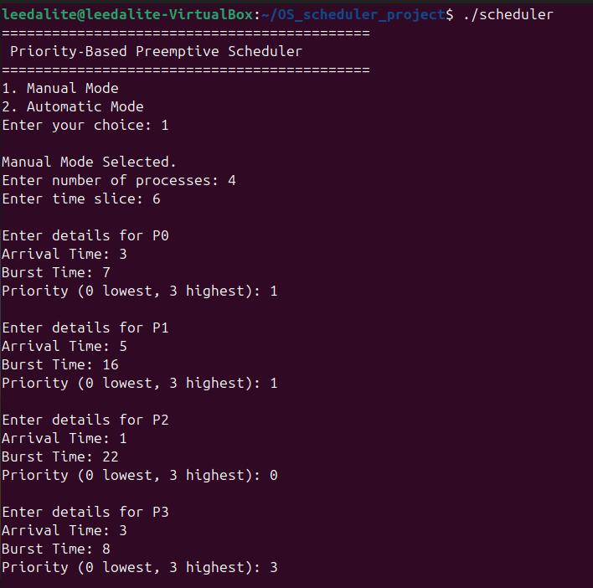

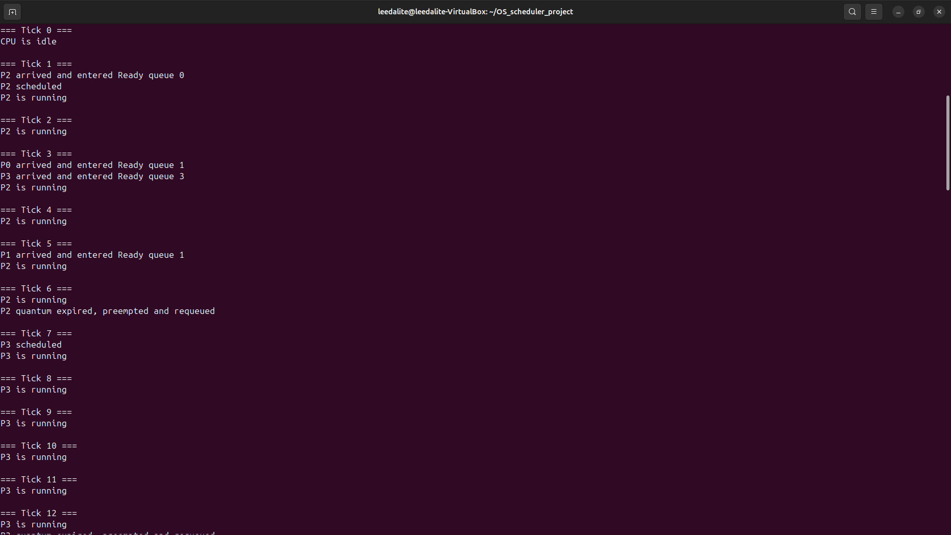

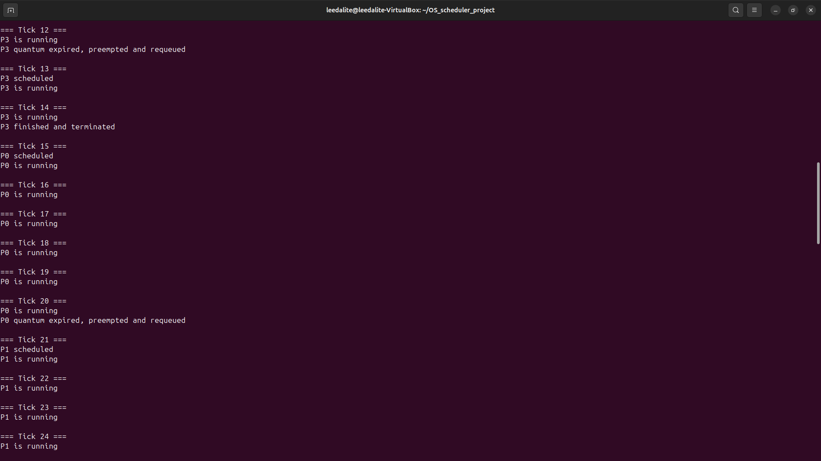

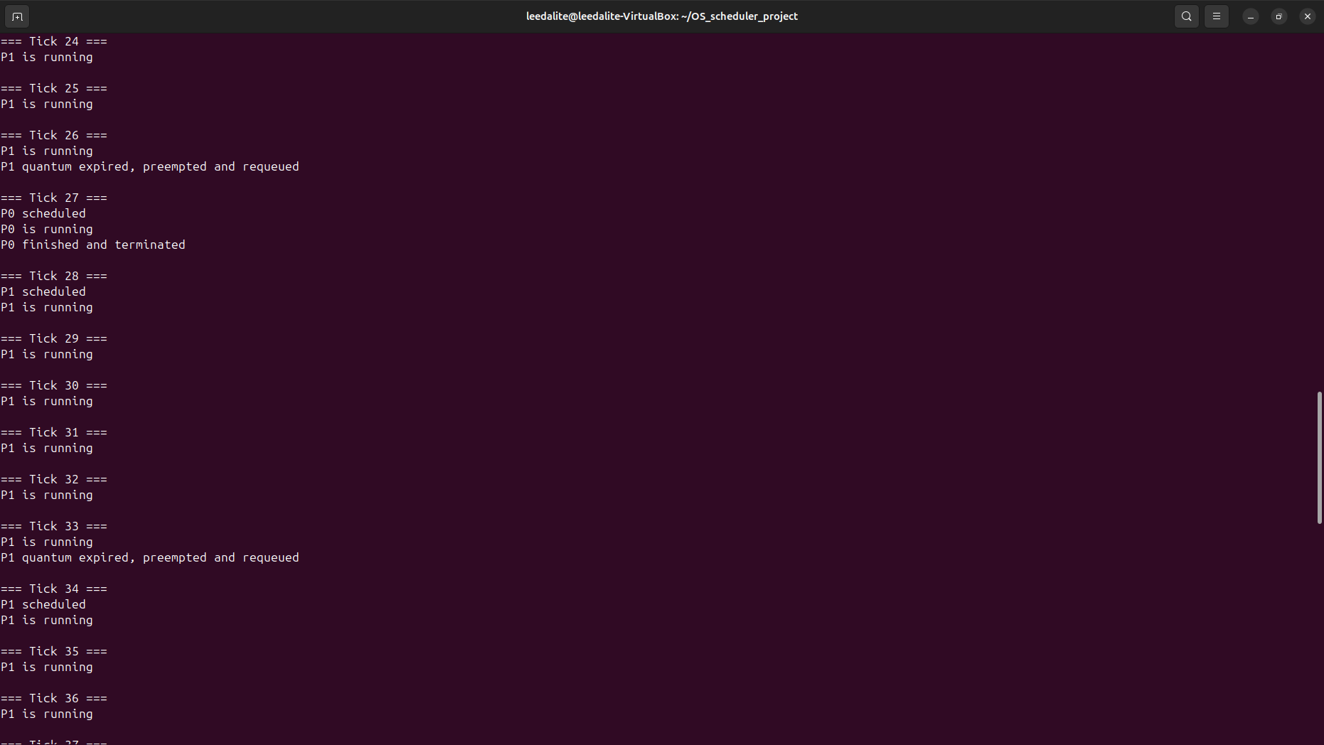

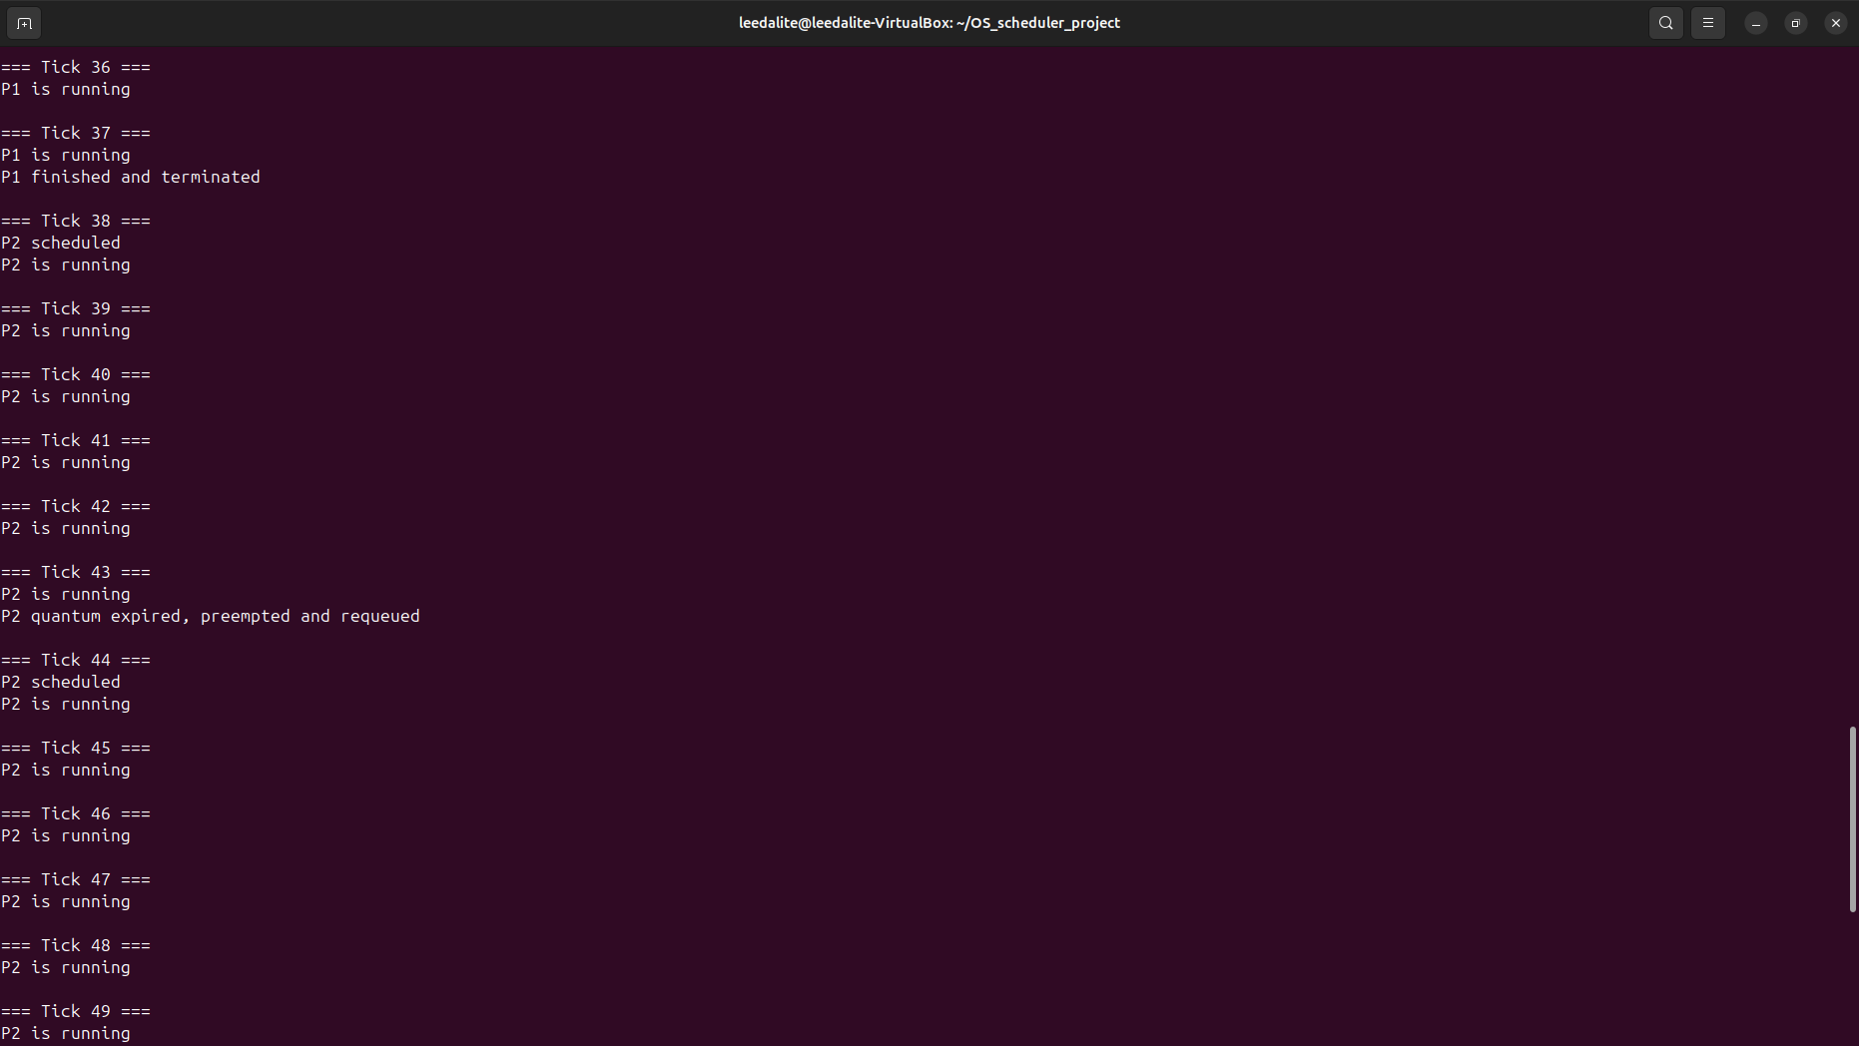

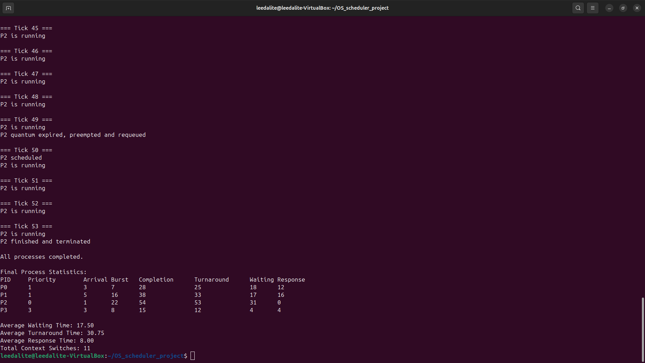

Eventually a rule will be added that if a higher-priority process arrives while a lower-priority process is running, the lower-priority process will be immediately preempted.

